Chillerton Village Petition Calls for 20mph speed limit around School
Press Release

• Nearly 300 residents and parents in the village of Chillerton have signed a petition calling for a 20mph limit around Chillerton and Rookley School, in the village.
• The petition was organized by the Parish Council over the last two months. Every home in the parish was contacted in person by a member of the Parish Council. More than 90 percent of residents supported the petition.
• Some 284 people signed the petition. Of those, 217 were residents. In addition, 67 parents of children at the school, and staff, also signed. Some 169 households in the parish were approached, and 158 responded.
• Parish Councillor Gillian Belben said: “Our children deserve the same level of protection that exists in their two sister schools in Wroxall and Godshill, both of which have a 20mph limit.”
• County Councillor Bob Seely said: “We’d like a 20mph limit around the school at opening and closing times because it will make picking up and dropping off children safer. There is a blind bend just before the school and there have been accidents and near misses.
• “This is an important project for Chillerton and the fact that so many people signed shows the strength of feeling – especially amongst parents. We’ve raised this issue on several occasions with IoW Council and we'll will keep doing so until we get the 20mph limit the village needs. Well done to Chillerton and Gatcombe Parish Council for their hard work organizing this petition.”
• Photos. We are organizing a time to present the petition to Cllr Phil Jordan and will send a photo when we have one. Please find enclosed photos of children in front of the school holding the petition:
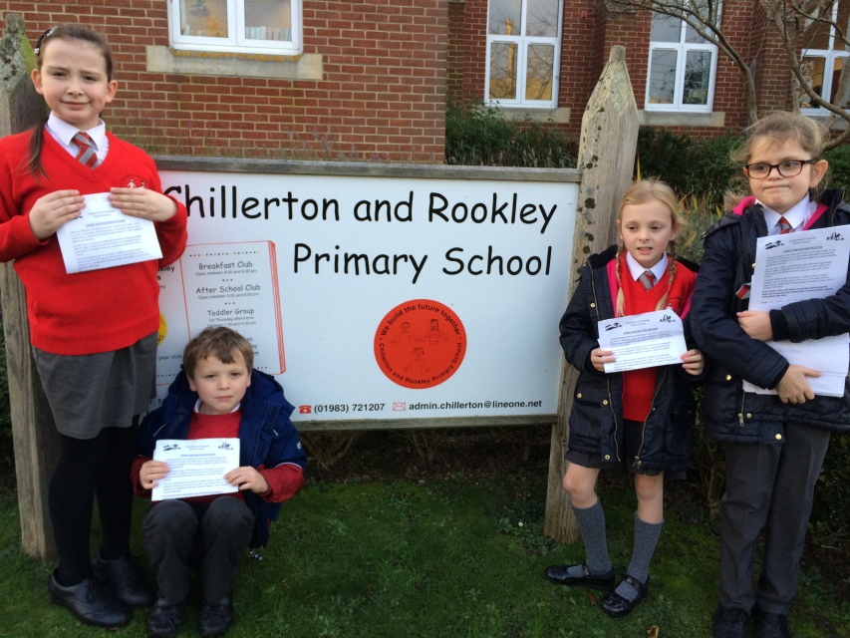
Left to right: Jessica Sweatman 9 , James Sweatman 4, Laila Evatt 8, Freya Evatt 10

